**AXA e-Notification Project**

**Interface Specification**

**Project Details**

|  |  |
| --- | --- |
| **Application Name** | AXA e-Notification Project |
| **Project No.** |  |
| **Project Name** | AXA e-Notification Project |

**Document Distribution List**

|  |  |  |
| --- | --- | --- |
| **To / CC** | **Name**  Firstname & Surname & Title | **Department** |
| To: |  |  |
| CC: |  |  |

**Document Control**

|  |  |  |  |  |
| --- | --- | --- | --- | --- |
| **Version**  **Number**  n.n | **Issued**  **On Date**  YYYY/MM/DD | **Author(s)**  Firstname & Surname  & Title | **Reviewer(s)**  Firstname & Surname  & Title | **Change Description** |
|  |  |  |  |  |
|  |  |  |  |  |

**TABLE OF CONTENTS**

1. OVERVIEW 4

1.1 APPLICATION INTERFACE DESIGN 5

1.1.1 Overall data flow diagram 5

1.1.2 iPro/SCRUM with NHR 6

1.1.2.1 Interface Purpose 6

1.1.2.2 Interface Type 6

1.1.2.3 Processing Time: 6

1.1.2.4 Interface Frequency 6

1.1.2.5 Expected Volume: 7

1.1.2.6 Data Process Flow 7

1.1.2.7 Failover or Alternative Flow 7

1.1.2.8 Data Element Definition 8

1.1.2.9 Interface Data Direction Relative to NHR System 2

1.1.2.10 Interface Log 2

1.1.2.11 Return Code Values 2

1.1.2.12 Overall format and sample layout 2

1.1.3 ICF with CG 8

1.1.3.1 Interface Purpose 8

1.1.1.1 Interface Type 10

1.1.1.2 Processing Time: 10

1.1.1.3 Interface Frequency 10

1.1.1.4 Expected Volume: 10

1.1.1.5 Data Process Flow 10

1.1.1.6 Failover or Alternative Flow 10

1.1.1.7 Data Element Definition 11

1.1.1.8 Interface Data Direction Relative to CG System 2

1.1.1.9 Interface Log 2

1.1.1.10 Return Code Values 2

1.1.1.11 Overall format and sample layout 3

1.1.2 Core System with CG 9

1.1.2.1 Interface Purpose 9

1.1.2.2 Interface Type 9

1.1.2.3 Processing Time: 9

1.1.2.4 Interface Frequency 9

1.1.2.5 Expected Volume: 9

1.1.2.6 Data Process Flow 9

1.1.2.7 Failover or Alternative Flow 10

1.1.2.8 Core System Interface File Definition 11

1.1.2.9 Interface Data Direction Relative to CG System 15

1.1.2.10 Interface Log 15

1.1.2.11 Return Code Values 15

1.1.2.12 Overall format and sample layout 15

# OVERVIEW

This document aims to describe the interfaces between eNotification System and Other systems. eNotification System consist of two major applications, Communication Gateway (CG) and Notification History Repository (NHR), locating in different network area and serving different functional purposes. The document would include below interfaces in detail level.

1. iPro/SCRUM with NHR – Notification History Enquiry.
2. iPro/SCRUM with CG – Notification Sending
3. Core Systems with CG – Notification File Upload (batch)

## APPLICATION INTERFACE DESIGN

### Overall data flow diagram

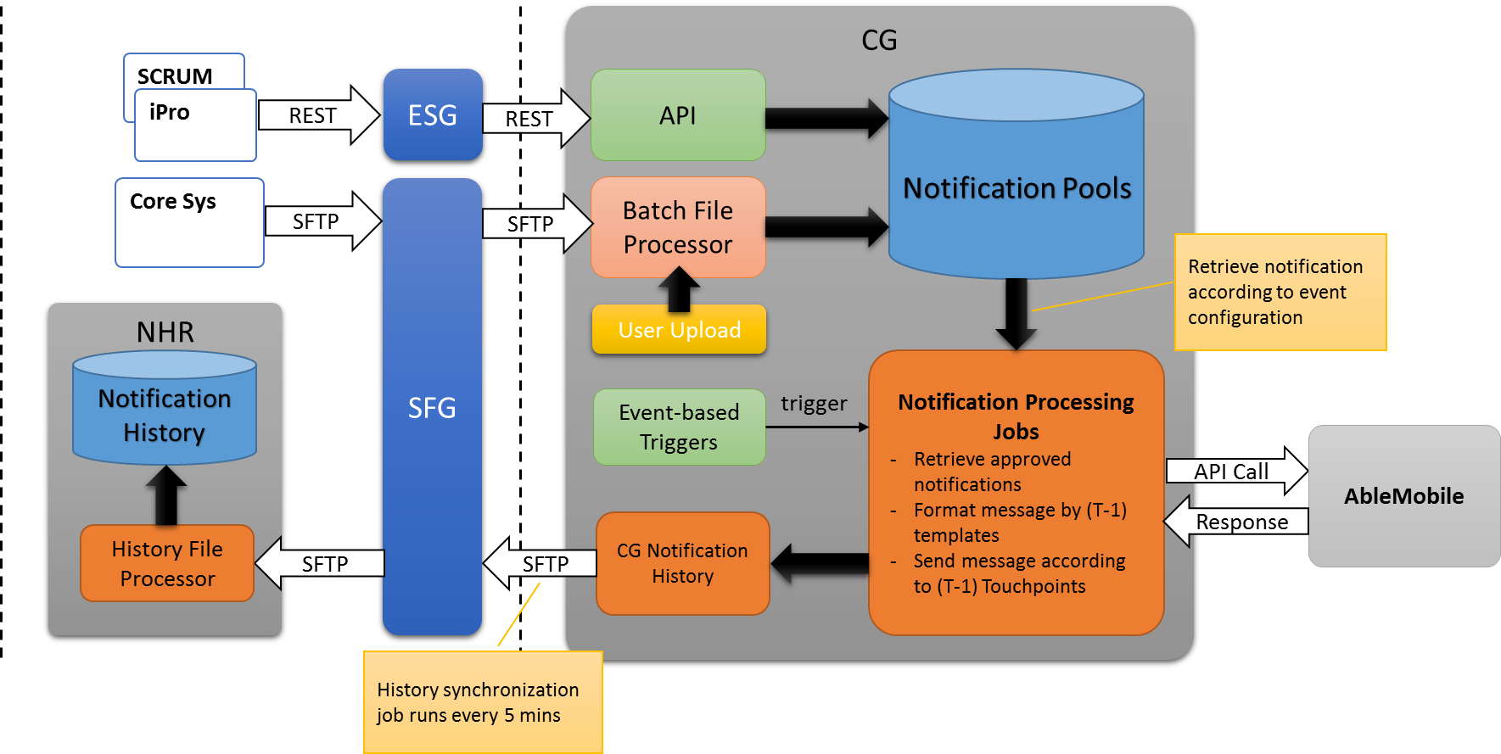

1. CG receives batch notification requests from Core Systems through SFG in a pre-difined time interval.
2. NHR receives on-demand notification request from iPro/SCRUM through ESG in real time.
3. CG shall process both batch notification requests and on-demand notification requests on each receive, and retain requests in CG’s notification pool.
4. On user’s creating Events, CG will generate schedule jobs on the basis of Event configuration (shedule time, touchpoints).
5. Schedul jobs will run by time triggers and retrive notificaiton request from the pool by the touchpoint criteria, send handle the message formatting and sending.
6. CG will be able to hanle the message sending through AbleMobile and its response result. Apart from this, CG will call AbleMobile to retrieve message delivery report to update CG’s notificatio status in a configurable time interval.
7. CG will synchronize the notfitication processing status to NHR by batch file in a configurable time interval.

### iPro/SCRUM with NHR

#### Interface Purpose

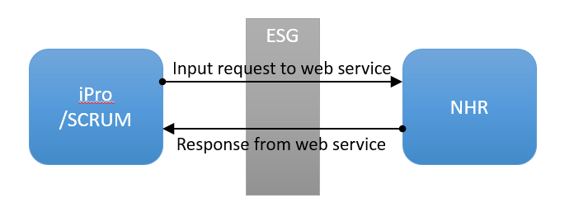

iPro/SCRUM is the application used by brokers and agents to view daily notification sending status and history.

The purpose of this interfaces are

1. A Web Service within NHR will be used for receiving the request and give the response to iPro/SCRUM system. The request sent by iPro/SCRUM will be defined as a proper object in WSDL while the Web Service response will be defined as a proper object as well
2. All timestamps are assumed to be in HKG local time (UTC+8)

#### Interface Type

|  |  |  |  |
| --- | --- | --- | --- |
|  | **Inbound** | **Outbound** | **Both** |
| REST |  |  | X |
| Web Service |  |  |  |
| FTP/SFTP |  |  |  |
| Manual |  |  |  |
| Direct File Access |  |  |  |

#### Processing Time:

Not applicable

#### Interface Frequency

On-demand

#### Expected Volume:

TBC

#### Data Process Flow

TBC

#### Failover or Alternative Flow

TBC

#### Data Element Definition

Notification History Enquiry Request Table

|  |  |  |  |  |  |  |  |
| --- | --- | --- | --- | --- | --- | --- | --- |
| **#** | **Field Name** | **Description** | **Is Required** | **Format** | **Remarks** | **XML Example** | **Json Example** |
| 1 | requestor | Fixed value | Y | String |  | <requestor>SCRUM  </requestor> | {“requestor”:”SCRUM”} |
| 2 | requestId | An unique uuid generated for the requestor | Y | String | REQ+ yyyymmddhh24miss+  Millisecond+  4 digits uuid | <requestId>  REQ201602260943185704e57  </requestId> | {“requestId”:”REQ201602260943185704e57”} |
| 3 | requestSource | The source the request from | Y | String | I – iPro  S - SCRUM | <requestSource>I</requestSource> | {“requestSource”:”I”} |
| 4 | requestDetail | List all request criteria | Y | String |  | <requestDetail>  Sub-element 5-19  </requestDetail> | {“requestDetail”:”Sub-element 5-19”} |
| 5 | Notification Type | Customer /  Channel Contact | N |  | * Customer * Channel Contact | <notificationType>  Customer  </notificationType> | {“notificationType”:”Customer”} |
| 6 | Custom Name | Custom name | N | String |  | <customName></customName> | {“customName”:””} |
| 7 | Claim No | Claim No | N | String |  | <claimNo></claimNo> | {“claimNo”:”C002”} |
| 8 | Touchpoint  Types | Touchpoint  Types | N | String | Touchpoint condition | <touchpointTypes>  <touchpointType>  LIF0004  </touchpointType>  <touchpointType>  LIF0005  </touchpointType>  <touchpointType>  LIF0008  </touchpointType>  </touchpointType> | {“touchpointTypes”:[”LIF0004”, “LIF0005”,”LIF0008”]} |
| 9 | policyNos | Policy Numbers | N | String | Maximum 2000 | <policyNos>  <policyNo>P392305531</policyNo>  <policyNo>P392305532</policyNo>  <policyNo>P392305533</policyNo>  </policyNos> | {“policyNos”:[“P392305531”,”P392305532”,”P392305533”]} |
| 10 | agentCodes | Agent/Broker Codes | N | String | Maximum 2000 | <agentCodes>  <agentCode>A43512323</agentCode>  <agentCode>A43512324</agentCode>  <agentCode>A43512325</agentCode>  </agentCodes> | {“agentCodes”:“[A43512323”,”A43512324”,”A43512325”]} |
| 11 | Message Types | SMS/Email/Agent Copy | N | String | 3 values  “Sms”  “Email”  “Channel_Only” – notification kept in the system as a copy for iPro’s query, in UI (same as iPro Only) | <msgTypes>  <msgType>sms</msgType>  <msgType>email<msg</msgType>  </msgTypes> | {“msgTypes”:[”sms”,”email”]} |
| 12 | Statuses | Notification Status | N | String | ==SMS==  S100 - DELIVERED  S102 - SENT  S110 - PENDING  S200 – UNDELIVERED  S201 – INVALID NUMBER  S202 - INVALID FORMAT  S203 - CALL BARRED  S204 - EXPIRED  S211 - BLACKLISTED  S212 - OFCA BLACKLISTED  ==Email==  E0 - OK  E2 – INVALID TOKEN  E3 – TOKEN EXPIRED  E10000 – MISSING PARAMETER  E10001 – MISSING CAMPAIGN NAME  E10002 – MISSING CONTENT TEXT  E10003 – MISSING SUBJECT  E10004 – MISSING SENDER MAIL  E10005 – MISSING SENDER NAME  E10006 – EIN CG003 – OPT OUT EMAIL ADDRESS  VALID SENDER MAIL  E10007 – INVALID RETURN MAIL  E10008 – INTERNAL ERROR  E10009 – CAMPAIGN NOT FOUND  E10010 - MISSING_CAMPAIGN_ID  E10011 – NO ACCESS RIGHT TO THIS CAMPAIGN  E10012 – CAMPAIGN STATE NOT ALLOW  E10013 – MISSING RECIPIENTS  E10014 – EXCEEDED NUMBER OF RECIPIENTS LIMIT  E10015 - UNAUTHORIZED  E10016 – INVALID RECIPIENT STATE  ==CG Status==  C1 – CG NEW  C2 – ABLEMOBILE SENT  C3 – OPT OUT EMAIL ADDRESS  C4 – OPT OUT MOBILE NUMBER | <statuses>  <status> S100</status>  <status>S102 </status>  <status>E10000 </status>  </statuses> | {“statuses”:[“S100  ”,”S102”,”S110”]} |
| 13 | Sent Start Time | SMS date range start time | N | yyyymmddhh24miss |  | <sentStartTime>  </sentStartTime> | {“sentStartTime”:”“} |
| 14 | Sent End Time | SMS date range end time | N | yyyymmddhh24miss |  | <sentEndTime>  </sentEndTime> | {“sentEndTime”:”“} |
| 15 | Deliver Start Time | SMS date range start time | N | yyyymmddhh24miss |  | <deliverStartTime>  </deliverStartTime> | {“deliverStartTime”:”“} |
| 16 | Deliver End Time | SMS date range end time | N | yyyymmddhh24miss |  | <deliverEndTime>  </deliverEndTime> | {“deliverEndTime”:”“} |
| 17 | Start From Row Number | The number of row number where record set starts from | N (if not input, default start from first record) | Numeric (8,0) |  | <startFrom>  41  </startFrom> | {“startFrom”:”“} |
| 18 | pageSize | Page Size | N | Numeric (3,0) |  | <pageSize>  40  </pageSize> | {“pageSize”:”“} |
| 19 | Sort | Sort By | N | String |  | <sort>  <by>field</by>  <order>desc | asc </order>  </Sort> | {“sort”:{“by:”:””,”order”:””}} |
| 20 | With Content Indicator | With content indicator | Y | String | When withContent = ‘Y’, the return result will have content field formatted.  When withContent = ‘N’, the return result’s content field will be blank.  *Validate the value is valid or not, if the parameter is neither “Y” nor “N”, return error “NHR1000 - Invalid Parameter” | <withContent>Y</withContent> | {“withContent”:”Y”} |

Notification History Enquiry Response Table

|  |  |  |  |  |  |  |  |
| --- | --- | --- | --- | --- | --- | --- | --- |
| **#** | **Field Name** | **Description** | **Is Required** | **Format** | **Remarks** | **Example** | **Json Example** |
| 1 | NHR Data Header | Fixed value | Y | String |  | <nhrHistoryDate sourceId=“NHR”> | {“nhrHistoryDate”:{“sourceId”:”NHR”}} |
| 2 | History Inquiry Info | Information to match the request | Y | String |  | <historyEnquiryInfo>  Sub-elements 3-8 here  </historyEnquiryInfo> | {“historyEnquiryInfo”:”Sub-elements 3-8 here  “} |
| 3 | Requestor | Fixed value | Y | String |  | <requestor>SCRUM  </requestor> | {“requestor”:”SCRUM”} |
| 4 | Request ID | Unique identification for request | Y | String | REQ+ yyyymmddhh24miss+  Millisecond+  4 digits uuid | <requestId>  REQ201602260943185704e57  </requestId> | {“requestId”:”REQ201602260943185704e57”} |
| 5 | Response ID | Unique identification for response | Y | String | RSP+ yyyymmddhh24miss+  Millisecond+  4 digits uuid | <responseId> RSP201602260943185196eb4  </responseId> | {“responseId”:”RSP201602260943185196eb4”} |
| 6 | Response Date Time | The timestamp for the response | Y | String |  | <responseDatetime>20160226094318570</responseDatetime> | {“responseDatetime”:”20160226094318570”} |
| 7 | Return Code |  | Y | String |  | <returnCode>  005  </returnCode> | {“returnCode”:”005”} |
| 8 | Error Message | The system error code received in case the error to be sent is not related to a particular request. | N | String |  | <errorMsg>  Requestor Not Found  </errorMsg> | {“errorMsg”:”Requestor Not Found”} |
| 9 | Number of Records | The number of records query | Y | Numeric |  | <numOfRecords>586< numOfRecords > | {“numOfRecords”:”586”} |
| 10 | Data Element | List all notification history records requested | Y (if no error) |  | *Maximum size of data returned: 2000 (when withContenct = ‘N’) | <data>  Sub-elements 10-25  </data> | {“data”:”Sub-elements 10-25”} |
| 11+ | Notification History ID | The unique key of the notification history | Y | Numeric |  | <notificationHistId>  1212121212  </notificationHistId> | {“notificationHistId”:”1212121212”} |
| 11 | Notification ID | Notification ID | Y | Numeric |  | <notificationId>  </notificationId> | {“notificationId”:”“} |
| 12 | Touchpoint Type Name | Touchpoint Type Description | Y | String |  | <touchpointTypeName>  </touchpointTypeName> | {“touchpointTypeName”:”“} |
| 13 | Touchpoint Subtype Name | Touchpoint Subtype Name | Y | String |  | <touchpointSubTypName>  </touchpointSubTypeName> | {“touchpointSubTypeName”:”“} |
| 14 | Approval Status | Approval Status | Y | String |  | <approvalStatus>  APPROVED  </approvalStatus> | {“approvalStatus”:”“} |
| 15 | Claim No | Claim No Value | N | String |  | <claimNo>317-294782342</claimNo> | {“claimNo”:”317-294782342”} |
| 16 | Policy No | Policy Number | N | String |  | <policyNo>P392305531</policyNo> | {“policyNo”:”P392305531”} |
| 17 | Agent Code | Agent/Broker Id | N | String |  | <agentCode>A43512323  </agentCode> | {“agentCode”:”A43512323”} |
| 18 | Email | Customer/Agent/Broker Email | N (either email or mobile is Y) | String |  | <recipientEmail>  agentCode@axa.com.hk  </recipientEmail> | {“recipientEmail”:”agentCode@axa.com.hk“} |
| 19 | Mobile | Customer/Agent/Broker Mobile | N (either email or mobile is Y) | String |  | <recipientMobile>  66666666  </recipientMobile> | {“recipientMobile”:”66666666”} |
| 20 | Message Type | Email/SMS | N | String | * Email * SMS * Agent Copy | <notificationType>  email  </notificationType> | {“notificationType”:”email”} |
| 21 | Subject |  | N | String |  | <subject>  </subject> | {“subject”:”“} |
| 22 | Message Content | The notification message content | N | String | When withContent = ‘N’, this field will be formatted blank | <content>message content</content> | {“content”:””} |
| 23 | Sent Time | The date time of sms being sent | N | yyyy-MM-dd'T'HH:mm:ss.SSS'Z' |  | <sentTime>  2016-08-08T14:18:57.977Z  </sentTime> | {“sentTime”:”2016-08-08T14:18:57.977Z”} |
| 24 | Deliver Time | The date time of sms being delivered | N | yyyy-MM-dd'T'HH:mm:ss.SSS'Z' |  | <deliverTime>  2016-08-08T14:18:57.977Z  </deliverTime> | {“deliverTime”:”2016-08-08T14:18:57.977Z”} |
| 25 | Send Status | Fixed value string for notification sending outcome | N | String |  | <sendStatus></sendStatus> | {“sendStatus”:”“} |
| 26 | Deliver Status | Fixed value string for notification delivery outcome | N | String | ==SMS==  DELIVERED  SENT  PENDING  UNDELIVERED  UNKNOWN SUBSCRIBER  INVALID FORMAT  CALL BARRED  EXPIRED  BLACKLISTED  OFCA BLACKLISTED  ==Email==  OK  INVALID TOKEN  TOKEN EXPIRED  MISSING PARAMETER  MISSING CAMPAIGN NAME  MISSING CONTENT TEXT  MISSING SUBJECT  MISSING SENDER MAIL  MISSING SENDER NAME  INVALID SENDER MAIL  INVALID RETURN MAIL  INTERNAL ERROR  CAMPAIGN NOT_FOUND  MISSING CAMPAIGN ID  NO ACCESS RIGHT TO THIS CAMPAIGN  CAMPAIGN STATE NOT ALLOW  MISSING RECIPIENTS  EXCEEDED NUMBER OF RECIPIENTS LIMIT  UNAUTHORIZED  INVALID RECIPIENT STATE | <deliverStatus>  SENT  </deliverStatus> | {“deliverStatus”:”“} |

#### Interface Data Direction Relative to NHR System

[ ] Inbound

[ ] Outbound

[ X ] Both (bi-directional)

#### Interface Log

TBC

#### Return Code Values

The values for reason codes and reason values are as below

|  |  |
| --- | --- |
| Error Code | Definition |
| NHR1000 | Invalid request parameters |
| NHR1001 | Requestor ID not found |
| NHR1002 | Request ID is not started with “REQ” |
| NHR1003 | Invalid email format |
| NHR1004 | Date range start time cannot be later than end time |
| TBC | … |
|  |  |

#### Overall format and sample layout

Notification History Enquiry Request

|  |
| --- |
| **application/xml, text/xml** |
| <request>  <requestor>SCRUM</requestor>  <requestId>REQ201602260943185704e57</requestId>  <requestSource>I</requestSource>  <requestDetail>  <notificationType>Customer</notificationType>  <customName/>  <claimNo>A232312112</claimNo>  <touchpointTypes><touchpointType>LIF0004</touchpointType></touchpointtTypes>  <policyNos>  <policyNo>P392305531</policyNo>  <policyNo>P392305532</policyNo>  <policyNo>P392305533</policyNo>  </policyNos>  <agentCodes>  <agentCode>A43512323</agentCode>  <agentCode>A43512324</agentCode>  <agentCode>A43512325</agentCode>  </agentCodes>  <msgTypes>  <msgType>sms</msgType>  <msgType>email</msgType>  </msgTypes>  <statuses>  <status>S100</status>  <status>S102</status>  <status>S110</status>  </statuses>  <sentStartTime>2016-08-08T14:18:57.977Z</sentStartTime>  <sentEndTime>2016-08-08T14:18:57.977Z</sentEndTime>  <deliverStartTime>2016-08-08T14:18:57.977Z</deliverStartTime>  <deliverEndTime/>  <startFrom>41</startFrom>  <pageSize>40</pageSize>  <sort>  <by>field</by>  <order>desc</order>  </sort>  <withContent>Y</withContent>  </requestDetail>  </request> |

|  |
| --- |
| **application/json, text/json** |
| {  "request": {  "requestor": "SCRUM",  "requestId": "REQ201602260943185704e57",  "requestSource": "I",  "requestDetail": {  "notificationType": "Customer",  "claimNo": "A232312112",  "touchpointTypes":["LIF0004","LIF0008"]},  "policyNos": {  "policyNo": [  "P392305531",  "P392305532",  "P392305533"  ]  },  "agentCodes": {  "agentCode": [  "A43512323",  "A43512324",  "A43512325"  ]  },  "msgTypes": {  "msgType": [  "sms",  "email"  ]  },  "statuses": {  "status": [  "S100",  "S102",  "S110"  ]  },  "sentStartTime": "2016-08-08T14:18:57.977Z",  "sentEndTime": "2016-08-08T14:18:57.977Z",  "deliverStartTime": "2016-08-08T14:18:57.977Z",  "startFrom": "41",  "pageSize": "40",  "sort": {  "by": "field",  "order": "desc"  },  "withContent":"Y"  }  }  } |

**Notification History Enquiry Response**

|  |
| --- |
| **application/xml, text/xml** |
| <nhrHistoryDate sourceId=“NHR”>  <historyEnquiryInfo>  <requestor>SCRUM</requestor>  <requestId>REQ201602260943185704e57</requestId>  <responseId> RSP201602260943185196eb4</responseId>  <responseDatetime>20160226094318570</responseDatetime>  <returnCode>005</returnCode>  <errorMsg>Requestor Not Found</errorMsg>  </historyEnquiryInfo>  <numOfRecords>564</numOfRecords >  < data >  <notificationHistId>1212121212</notificationHistId>  <notificationId>123002345</notificationId>  <touchpointTypeName>LIF0004</touchpointTypeName>  <touchpointSubTypeName>NOR</touchpointSubTypeName>  <approvalStatus>APPROVED</approvalStatus>  <claimNo>A3434323</claimNo>  <policyNo>P392305531</policyNo>  <agentCode>A43512323</agentCode>  <email>agentCode@axa.com.hk</email>  <mobile>66666666</mobile>  <sentTime>2016-08-08T14:18:57.977Z </sentTime>  <deliverTime>2016-08-08T14:18:57.977Z </deliverTime>  <sendStatus>SENT</sendStatus>  <deliverStatus>DELIVERED</deliverStatus>  <subject>Email Subject here...</subject>  </data >  <data>  <notificationHistId>1212121212</notificationHistId>  <notificationId>123002345</notificationId>  <touchpointTypeName>Touchpoint Type</touchpointTypeName>  <touchpointSubTypeName>NOR</touchpointSubTypeName>  <approvalStatus>APPROVED</approvalStatus>  <claimNo>A3434323</claimNo>  <policyNo>P392305531</policyNo>  <agentCode>A43512323</agentCode>  <email>agentCode@axa.com.hk</email>  <mobile>66666666</mobile>  <sentTime>2016-08-08T14:18:57.977Z </sentTime>  <deliverTime>2016-08-08T14:18:57.977Z </deliverTime>  <sendStatus>SENT</sendStatus>  <deliverStatus>DELIVERED</deliverStatus>  <subject>Email Subject here...</subject>  </ data >  < data >  <notificationId>123002345</notificationId>  <touchpointTypeName>Touchpoint Type</touchpointTypeName>  <touchpointSubTypeName>NOR</touchpointSubTypeName>  <approvalStatus>APPROVED</approvalStatus>  <claimNo>A3434323</claimNo>  <policyNo>P392305531</policyNo>  <agentCode>A43512323</agentCode>  <email>agentCode@axa.com.hk</email>  <mobile>66666666</mobile>  <sentTime>2016-08-08T14:18:57.977Z </sentTime>  <deliverTime>2016-08-08T14:18:57.977Z </deliverTime>  <sendStatus>SENT</sendStatus>  <deliverStatus>DELIVERED</deliverStatus>  <subject>Email Subject here...</subject>  </data>  </nhrHistoryData> |

|  |
| --- |
| **application/json, text/json** |
| {  “nhrHistoryDate”: {  “sourceId”: “NHR”,  “historyEnquiryInfo”: {  “requestor”: “SCRUM”,  “requestId”: “REQ201602260943185704e57”,  “responseId”: “ RSP201602260943185196eb4”,  “responseDatetime”: “20160226094318570”,  “returnCode”: “005”,  “errorMsg”: “Requestor Not Found”  }, “numOfRecords”:”586”, “data”: [  {  “notificationId”: “123002345”,  “touchpointTypeName”:”LIF0004”,  “touchpointSubTypeName”:”NOR”,  “approvalStatus”: “APPROVED”,  “claimNo”: “A3434323”,  “policyNo”: “P392305531”,  “agentCode”: “A43512323”,  “email”: “agentCode@axa.com.hk”,  “mobile”: “66666666”,  “sentTime”: “20160129141357”,  “deliverTime”: “20160129141357”,  “sendStatus”:”SENT”,  “deliverStatus”: “DELIVERED”,  “emailSubject”: “Email Subject here...” },  {  “notificationId”: “123002345”,  “touchpointTypeName”:””,  “touchpointSubTypeName”:”NOR”,  “approvalStatus”: “APPROVED”,  “claimNo”: “A3434323”,  “policyNo”: “P392305531”,  “agentCode”: “A43512323”,  “email”: “agentCode@axa.com.hk”,  “mobile”: “66666666”,  “sentTime”: “20160129141357”,  “deliverTime”: “20160129141357”,  “sendStatus”:”SENT”,  “deliverStatus”: “DELIVERED”,  “emailSubject”: “Email Subject here...” },  {  “notificationId”: “123002345”,  “touchpointTypeName”:””,  “touchpointSubTypeName”:”NOR”,  “approvalStatus”: “APPROVED”,  “claimNo”: “A3434323”,  “policyNo”: “P392305531”,  “agentCode”: “A43512323”,  “email”: “agentCode@axa.com.hk”,  “mobile”: “66666666”,  “sentTime”: “20160129141357”,  “deliverTime”: “20160129141357”,  “sendStatus”:”SENT”,  “deliverStatus”: “DELIVERED”,  “emailSubject”: “Email Subject here...” }  ]  }  } |

### ICF with CG

#### Interface Purpose

|  |  |  |
| --- | --- | --- |
| Parameter | Request Source | Sample |
| Case I | json | /axa-notification-web/spring/cg/sendNotificationByJson |
| Case II | xml | /axa-notification-web/spring/cg/sendNotificationByXml |

The interface will be able to handle 2 types of notification sending.

* + - 1. Touchpoint-based notification which process the notification sources which follows the pre-defined field mapping
      2. Touchpoint-based notification but its content is immediately processed, formatted and sent out.

**Touchpoint-based Notification**

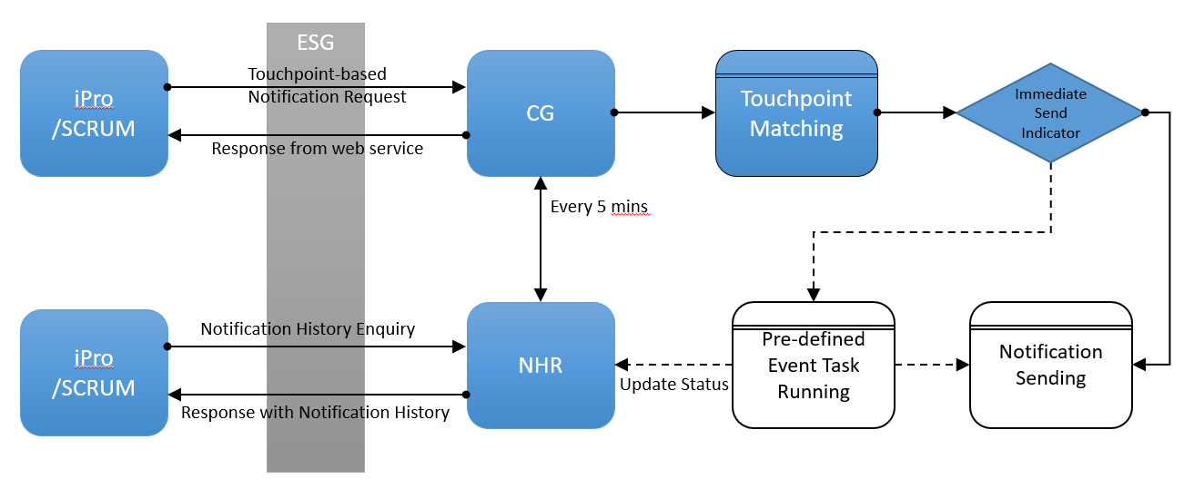

1 Touchpoint-based Notification Request

iPro/SCRUM will be able to send notification sources via the service provided by CG, in order to pre-book a scheduled notification sending. The sending is determined by the pre-defined event which takes over the corresponding Touchpoint.

The purpose of this interfaces is to

1. A Web Service within CG will be used for receiving the notification sending request. Upon receiving and validation, the request will write received notification source in CG’s source table with matched with correct Touchpoint and eventually give the response to iPro/SCRUM system.
2. Service responds upon the success/failure of the processing of the request. Successful response will contain the processed content of the notification source for client’s track record.
3. If the immediate send indicator is N or defaulted N, the handling of notification via this interface will be the same as that of batch file processing. Hence, iPro/SCRUM will be able to enquire the deliver status via the web service to NHR. Otherwise, the notification will be immediately processed and promptly sent to AbleMobile.

**Other key assumptions**

1. All timestamps are assumed to be in HKG local time (UTC+8)
2. Assumption is made that the iPro/SCRUM’s access to CG is certified private key basis so that no authentication process is needed before the actual sending request called. Or the web service is wrapped and encapsulated by enterprise service bus product provided by the client

#### Interface Type

|  |  |  |  |
| --- | --- | --- | --- |
|  | **Inbound** | **Outbound** | **Both** |
| REST |  |  | X |
| Web Service |  |  |  |
| FTP/SFTP |  |  |  |
| Manual |  |  |  |
| Direct File Access |  |  |  |

#### Processing Time:

Not applicable

#### Interface Frequency

On-demand

#### Expected Volume:

TBC

#### Data Process Flow

TBC

#### Failover or Alternative Flow

* Touchpoint-based notification can be manually uploaded source from CG’s UI
* One-time notification event can be manually created and maintained from CG’s UI

#### Data Element Definition

Touchpoint-based Notification Sending Request Table

|  |  |  |  |  |  |  |  |
| --- | --- | --- | --- | --- | --- | --- | --- |
| **#** | **Field Name** | **Description** | **Is Required** | **Format**  **A- Character**  **N-Numeric** | **Remarks** | **Example** | **Json Example** |
| 1 | Requestor | Fixed value | Y | A | Alias name which represents the request system.  For reference only. | <requestor>SCRUM  </requestor> | {“requestor”:”SCRUM”} |
| 2 | Request ID | An unique uuid generated for the requestor | Y | A (24) | REQ+ yyyymmddhh24miss+  Millisecond+  4 digits uuid | <requestId>  REQ201602260943185704e57  </requestId> | {“requestId”:”REQ201602260943185704e57”} |
| 3 | Request Source | The source the request from | Y | A | I – iPro  S – SCRUM | <requestSource>I</requestSource> | {“requestSource”:”I”} |
| 4 | Notification Header | Notification Header wrapper | Y | A |  | < notificationHeader >  Sub-element 5-10  </ notificationHeader > | {“notificationHeader”:”Sub-element 5-10”} |
| 5 | Notification Date | Notification Date | N | A (8) | YYYYMMDD  If it is left blank or the request does not contain this element, the system will assign current date to this value. | <notificationDate>20161101</ notificationDate > | {“notificationDate”:”20161101”} |
| 6 | Application ID | Which System the notification sending is requested from | Y | A (20) | IPRO – iPro  SCRUM - SCRUM | < appId >IPRO</ appId> | {“appId”:”IPRO”} |
| 7 | Business Line | Business Line Code (Abbreviation) | Y | A (10) | Value are defined in the system. View Business Line maintenance page | <businessLine>IL  </businessLine> | {“businessLine”:”IL} |
| 8 | Message Type ID | A Touchpoint Type | Y | A (50) |  | <msgTypeId>PNC0005</ msgTypeId > | {“msgTypeId”:”PNC0005”} |
| 9 | Immediate Send Indicator | A indicator defining the system’s operation after the notification source being processed | N | A (1) | Y – The notifications will be sent upon its reception  N – The notifications will be received but being sent when the Touchpoint event picks them up  If leaving it blank or the element not included, the default value will be ‘N’ | <immediateSend>Y</immediateSend> | {“immediateSend”:”Y”} |
| 10 | Field Mappings | Fields those contained in the notification body | N | A (*) | - | < fieldMappings >  Multiple Sub-element 11  </fieldMappings > | {“fieldMappings”:“[Multiple Sub-element 11]”} |
| 11 | Field Mapping Detail |  | N | A (*) | 3 Attributes  Name  Sequence  Length | <fieldMappingDetail name="PRODUCT_CODE" sequence="1" length="10" /> | {"@name": "PRODUCT_CODE","@sequence": "1","@length": "10"} |
| 12 | Notifications | Notification Collection Wrapper | Y | A | - | < notifications >  Sub-element 12-14  </policyNos> | {“notifications”:“[Sub-element 12-14]”} |
| 13 | Notification | Notification Wrapper | Y | A | - | <notification> Sub-element 13-20</notification> | {“notification”:“[Sub-element 13-20]”} |
| 14 | Approval Required Indicator | Approval Required Indicator | Y | A (1) | Y – approval required  N – approval not required | <approvalReq>Y  </approvalReq > | {“ approvalReq”:”Y”} |
| 15 | Field mapping values | The wrapper for notification content which is presented as multiple field mapping details | Y | A (*) | - | <fieldMappingValues>[multiple sub element 16]  </fieldMappingValues > | {“fieldMappingValues”:”[multiple sub element 16]”} |
| 16 | Field Mapping Value | The detail value of each field | Y | A (*) | 2 Attributes  Name – must be the same as the system field name in the field mapping setting  Value – must be within the length and correct format | <fieldMappingValue name="URL" value="http://this.is.a.sample.url.com/" /> | {"@name": "PRODUCT_CODE","@value": "EAC"} |

**Proposed Content Field Mapping**

|  |  |  |  |  |  |  |  |
| --- | --- | --- | --- | --- | --- | --- | --- |
| **Field Name**  **(System)** | **Field Name**  **(Display)** | **Field**  **Length** | **Field**  **Seq** | **Map to Standard Field** | **Allow**  **Data**  **Masking** | **Groupable**  **(As Placeholder**  **in Template)** | **Remarks**  **(Not a Field**  **in DB)** |
| PRODUCT_CODE | Product Code | 10 | 1 | Product_Code | N | Y | A factor to determine the notification Touchpoint & usually leave blank if apply to all. |
| CHANNEL_TYPE | Channel Type | 4 | 2 | Channel_Type | N | Y | A factor to determine the notification Touchpoint & usually leave blank if apply to all. |
| SUB_TYPE | Sub Type | 30 | 3 | Sub_Type | N | Y | A factor to determine the notification Touchpoint & usually leave blank if apply to all. |
| POLICY_NO | Policy No | 30 | 4 | Policy_No | N | Y |  |
| CSC | CSC | 30 | 5 |  | N | Y | The CSC & Combination will define the notification language. |
| PRE_LANG | Prefer Language | 30 | 6 | Preferred_Language | N | Y |
| CUST_MOBILE | Customer Mobile | 30 | 7 | Customer_Mobile | N | Y | Customer or Agent’s contact points. These field can be input blank but no system action will be performed if the notification has neither customer contacts nor agent contacts. |
| CUST_EMAIL | Customer Email | 100 | 8 | Customer_Email | N | Y |
| ID | Agent ID | 30 | 9 | Channel_Contact_Id | N | Y |
| MOBILE | Agent Mobile | 30 | 10 | Channel_Contact_Mobile | N | Y |
| EMAIL | Agent Email | 100 | 11 | Channel_Contact_Emamil | N | Y |
| URL | url | 200 | 12 |  | N | Y |  |

Touchpoint-based Notification Sending Response Table

|  |  |  |  |  |  |  |  |
| --- | --- | --- | --- | --- | --- | --- | --- |
| **#** | **Field Name** | **Description** | **Is Required** | **Format**  **A- Character**  **N-Numeric** | **Remarks** | **Example** | **Json Example** |
| 1 | CG Source ID | Fixed value | Y | A |  | <sourceId>CG  </sourceId> | {“cgNotification”:{“sourceId”:”CG”}} |
| 2 | Response Info | Information to match the request | Y | A |  | <responseInfo>  Sub-elements 3-8 here  </ responseInfo > | {“responseInfo”:”Sub-elements 3-8 here  “} |
| 3 | Requestor | Fixed value | Y | A |  | <requestor>SCRUM  </requestor> | {“requestor”:”SCRUM”} |
| 4 | Request ID | Unique identification for request | Y | A (24) | REQ+ yyyymmddhh24miss+  Millisecond+  4 digits uuid | <requestId>  REQ201602260943185704e57  </requestId> | {“requestId”:”REQ201602260943185704e57”} |
| 5 | Response ID | Unique identification for response | Y | A (24) | RSP+ yyyymmddhh24miss+  Millisecond+  4 digits uuid | <responseId> RSP201602260943185196eb4  </responseId> | {“responseId”:”RSP201602260943185196eb4”} |
| 6 | Response Date Time | The timestamp for the response | Y | Datetime | yyyymmddhh24miss+  Millisecond | <responseDatetime>20160226094318570  </responseDatetime> | {“responseDatetime”:”20160226094318570”} |
| 7 | Return Code | Return Code | Y | A (12) | 0 – Successful  Other –refer to error code mapping | <returnCode>  CG1000  </returnCode> | {“returnCode”:”CG1000”} |
| 8 | Error Message | The system error code received in case the error to be sent is not related to a particular request. | N | A (200) |  | <errorMsg>  Requestor Not Found  </errorMsg> | {“errorMsg”:”Requestor Not Found”} |
| 10 | Notifications | Notification Collection Wrapper | Y | A | - | < notifications >  Sub-element 11-29  </ Notifications > | {“notifications”:“[Sub-element 11-29]”} |
| 11 | Notification | Notification Wrapper | Y | A | - | <notification> Sub-element 12-29</notification> | {“notification”:“[Sub-element 12-29]”} |
| 12 | Notification ID | Notification ID | Y | N (19,0) | Notification Unique Key | <notificationId>  768  </notificationId> | {“notificationId”:” 768 “} |
| 13 | Approval Required | Approval Required Indicator | Y | N (1) | Y – Yes  N – No | <approvalReq>  </approvalReq> | {“approvalReq”:”1”} |
| 14 | Approval Status | Approval Status | Y | A (20) |  | <approvalStatus>  APPROVED  </approvalStatus> | {“approvalStatus”:”APPROVED”} |
| 15 | Approval Time | Approval Time | Y | Datetime | + yyyymmddhh24miss+  Millisecond | <approvalTime>  </approvalTime> | {“approvalTime”:””} |
| 16 | Approver | Approver | N | A (32) | Default return blank. If approval required flag is N, the value will be “SYSTEM” | <approver> |  |
| 17 | Branch Code | Branch Code | N | A( 32) |  | <branchCode>  </branchCode> | {“ branchCode”:””} |
| 18 | Notification Send Type | Notification Send Type | N | A (20) | RECURRENT – the notification will be picked up and sent by recurrent events | <sendType>RECURRENT  </sendType> | {“sendType”:”RECURRENT”} |
|  | Business Line | Notification Business | N | A () |  | <businessLine>GH  </businessLine> |  |
| 19 | Touchpoint Type | Touchpoint Type | N | A (50) |  | <touchpointType>  </touchpointType> | {“touchpointType”:””} |
| 20 | Touchpoint Type Description | Touchpoint Type Description/Name | Y | A (500) |  | <touchpointTypeName>  New Business Issuance  </touchpointTypeName> | {“touchpointTypeName”:” New Business Issuance “} |
| 21 | Policy No | Policy Number | Y | A (100) |  | <policyNo>P392305531</policyNo> | {“policyNo”:”P392305531”} |
| 22 | Agent Code | Agent/Broker Id | N | A (100) |  | <agentCode>A43512323  </agentCode> | {“agentCode”:”A43512323”} |
| 23 | Agent Email | Agent Email | N | A (100) |  | <agentEmail>  agentCode@axa.com.hk  </agentEmail> | {“agentEmail”:”agentCode@axa.com.hk”} |
| 24 | Agent Mobile | Agent Mobile | N | A (20) |  | <agentMobile>  66666666  </agentMobile> | {“agentMobile”:”66666666”} |
| 25 | Email | Customer Email | N (either email or mobile is Y) | A (100) |  | <email>  customer@axa.com.hk  </email> | {“mail”:”customer@axa.com.hk”} |
| 26 | Mobile | Customer Mobile | N (either email or mobile is Y) | A (20) |  | <mobile>  66666666  </mobile> | {“mobile”:”66666666”} |
| 27 | Preferred Language | Preferred Language | Y | A (20) | EN –English  ZH-CN – Simplified Chinese  ZH-HK – Traditional Chinese  *Note: CG’s preferred language is justified by “preferred language” and “CSC” fields in the source* | <preferredLang>  EN  </preferredLang > | {“preferredLang”:”EN”} |
| 28 | Status | Send Status | Y | A (20) | Then notification is newly added, so the send status will be empty.  If its approval required flag is ‘N’, the status will be “PENDING”  If the “Immediate Send Indicator = ‘Y’, which means CG has prompted the sending to AbleMobile. This status should be “SENT” | <status></status> | {“status”:””} |
| 29 | Content | Notification Content | N | A (*) | Formatted JSON content generated from the original fix length plain text | <content>  </content> | {“content”:”“} |

#### Interface Data Direction Relative to CG System

[ ] Inbound

[ ] Outbound

[ X ] Both (bi-directional)

#### Interface Log

TBC

#### Return Code Values

The values for reason codes and reason values are as below

|  |  |
| --- | --- |
| **Return Code** | **Definition** |
| 0 | Successful |
| CG1000 | Invalid request parameter |
| CG1001 | Requestor ID not found |
| CG1002 | Request ID is not started with “REQ” |
| CG1003 | Invalid email format |
| CG1004 | Notification send time must be later than current time |
| CG1005 | Business Line [value] not found |
| CG1006 | Sub Business Line [value] not found |
| CG1007 | Touchpoint/Message Type [value] not found |
| CG1008 | Message Sub-type [value] not found |
| CG1009 | Channel [value] not found |
| CG1010 | Touchpoint cannot be matched |
| CG1011 | Product [value] not found |
|  |  |

#### Overall format and sample layout

Touchpoint-based Notification Sending Request

|  |
| --- |
| **application/xml, text/xml** |
| <request>  <requestor>SCRUM</requestor>  <requestId>REQ201602260943185704e57</requestId>  <requestSource>I</requestSource>  <notificationHeader>  <notificationDate>20161101</notificationDate>  <appId>IPRO</appId>  <businessLine>IL</businessLine>  <msgTypeId>PNC0005</msgTypeId>  <immediateSend>Y</immediateSend>  <fieldMappings>  <fieldMappingDetail name="PRODUCT_CODE" sequence="1" length="10" />  <fieldMappingDetail name="CHANNEL_TYPE" sequence="2" length="4" />  <fieldMappingDetail name="SUB_TYPE" sequence="3" length="30" />  <fieldMappingDetail name="POLICY_NO" sequence="4" length="30" />  <fieldMappingDetail name="CSC" sequence="5" length="30" />  <fieldMappingDetail name="PRE_LANG" sequence="6" length="30" />  <fieldMappingDetail name="CUST_MOBILE" sequence="7" length="30" />  <fieldMappingDetail name="CUST_EMAIL" sequence="8" length="100" />  <fieldMappingDetail name="ID" sequence="9" length="30" />  <fieldMappingDetail name="MOBILE" sequence="10" length="30" />  <fieldMappingDetail name="EMAIL" sequence="11" length="100" />  <fieldMappingDetail name="URL" sequence="12" length="200" />  </fieldMappings>  </notificationHeader >  <notifications>  <notification>  <approvalReq>Y</approvalReq>  <fieldMappingValues>  <fieldMappingValue name="PRODUCT_CODE" value="EAC" />  <fieldMappingValue name="CHANNEL_TYPE" value="O" />  <fieldMappingValue name="SUB_TYPE" value="" />  <fieldMappingValue name="POLICY_NO" value="04960801GH" />  <fieldMappingValue name="CSC" value="" />  <fieldMappingValue name="PRE_LANG" value="E" />  <fieldMappingValue name="CUST_MOBILE" value="99999999" />  <fieldMappingValue name="CUST_EMAIL" value="denise.lau.sss@axa.com.hk" />  <fieldMappingValue name="ID" value="92014" />  <fieldMappingValue name="MOBILE" value="9201403064340" />  <fieldMappingValue name="EMAIL" value="Krishina.datla.sss@axa.com.hk " />  <fieldMappingValue name="URL" value="http://this.is.a.sample.url.com/" />  </fieldMappingvalues>  </notification>  </notifications>  </request> |

|  |
| --- |
| **application/json, text/json** |
| {  "requestor": "SCRUM",  "requestId": "REQ201602260943185704e57",  "requestSource": "I",  "notificationHeader": {  "notificationDate": "20161101",  "appId": "IPRO",  "businessLine": "IL",  "msgTypeId": "PNC0005",  "immediateSend": "Y",  "fieldMappings": [  {"name": "PRODUCT_CODE","sequence": "1","length": "10"},  {"name": "CHANNEL_TYPE","sequence": "2","length": "4"},  {"name": "SUB_TYPE","sequence": "3","length": "30"},  {"name": "POLICY_NO","sequence": "4","length": "30"},  {"name": "CSC","sequence": "5","length": "30"},  {"name": "PRE_LANG","sequence": "6","length": "30"},  {"name": "CUST_MOBILE","sequence": "7","length": "30"},  {"name": "CUST_EMAIL","sequence": "8","length": "100"},  {"name": "ID","sequence": "9","length": "30"},  {"name": "MOBILE","sequence": "10","length": "30"},  {"name": "EMAIL","sequence": "11","length": "100"},  {"name": "URL","sequence": "12","length": "200"}  ]  },  "notifications": {  "notification": {  "approvalReq": "Y",  "fieldMappingValues": [  {"name": "PRODUCT_CODE","value": "EAC"},  {"name": "CHANNEL_TYPE","value": "O"},  {"name": "SUB_TYPE","value": ""},  {"name": "POLICY_NO","value": "04960801GH"},  {"name": "CSC","value": ""},  {"name": "PRE_LANG","value": "E"},  {"name": "CUST_MOBILE","value": "99999999"},  {"name": "CUST_EMAIL","value": "denise.lau.sssaxa.com.hk"},  {"name": "ID","value": "92014"},  {"name": "MOBILE","value": "9201403064340"},  {"name": "EMAIL","value": "Krishina.datla.sssaxa.com.hk"},  {"name": "URL","value": "http://this.is.a.sample.url.com/"}  ]  }  }  } |

Touchpoint-based Notification Sending Response

|  |
| --- |
| **application/xml, text/xml** |
| <response>  <sourceId>CG</sourceId>  <responseInfo>  <requestor>SCRUM</requestor>  <requestId>REQ201602260943185704e57</requestId>  <responseId> RSP201602260943185196eb4</responseId>  <responseDatetime>20160226094318570</responseDatetime>  <returnCode>CG1000</returnCode>  <errorMsg>Requestor Not Found</errorMsg>  </responseInfo >  <notifications >  <notification>  <notificationId>7689</notificationId>  <notificationDate>2016-12-12</notificationDate>  <approvalReq>N</approvalReq>  <approvalStatus>APPROVED</approvalStatus>  <approvalTime>2016-11-22 15:44:28.593</approvalTime>  <approver>SYSTEM</approver>  <branchCode>1213</branchCode>  <sendType>RECURRENT</sendType>  <businessLine>GH</businessLine>  <touchpointTypeName>New Business Issuance</touchpointTypeName>  <policyNo>04357501GH</policyNo>  <agentCode>A43512323</agentCode>  <agentEmail>agentCode@axa.com.hk</agentEmail>  <agentMobile>66666666</agentMobile>  <email>customer@axa.com.hk</email>  <mobile>66666666</mobile>  <preferredLang>EN</preferredLang >  <status>ABLEMOBILE-SENT</status>  <content>{"LANGUAGE":"C","CUSTOMER EMAIL ADDR":"","CHANNEL TYPE":"NOR","STATUS CODE":"25","TRANSACTION DATE":"20161212","SUB TYPE":"","CUSTOMER MOBILE NO":"91763383","POLICY NO":"302-5914437","EMAIL":"","PRODUCT_CODE":"ALL","AGENCY/ BROKER ID":"24735","CSC":"","TRANSACTION CODE":"V","UNIT CODE":"620008","MOBILE":""}  </content>  </notification>  </notifications>  </response> |

|  |
| --- |
| **application/json, text/json** |
| {  "cgNotification": {  "sourceId": "CG",  "responseInfo": {  "requestor": "SCRUM",  "requestId": "REQ201602260943185704e57",  "responseId": " RSP201602260943185196eb4",  "responseDatetime": "20160226094318570",  "returnCode": "CG1000",  "errorMsg": "Requestor Not Found"  },  "notifications": {  "notification": {  "notificationId": "7689",  "notificationDate": "2016-12-12",  "approvalReq": "N",  "approvalStatus": "APPROVED",  "approvalTime": "2016-11-22 15:44:28.593",  "approver": "SYSTEM",  "branchCode": "1213",  "sendType": "RECURRENT",  "businessLine": "GH",  "touchpointTypeName": "New Business Issuance",  "policyNo": "04357501GH",  "agentCode": "A43512323",  "agentEmail": "agentCode@axa.com.hk",  "agentMobile": "66666666",  "email": "customer@axa.com.hk",  "mobile": "66666666",  "preferredLang": "EN",  "status": "ABLEMOBILE-SENT",  "content": "{\"LANGUAGE\":\"C\",\"CUSTOMER EMAIL ADDR\":\"\",\"CHANNEL TYPE\":\"NOR\",\"STATUS CODE\":\"25\",\"TRANSACTION DATE\":\"20161212\",\"SUB TYPE\":\"\",\"CUSTOMER MOBILE NO\":\"91763383\",\"POLICY NO\":\"302-5914437\",\"EMAIL\":\"\",\"PRODUCT_CODE\":\"ALL\",\"AGENCY/ BROKER ID\":\"24735\",\"CSC\":\"\",\"TRANSACTION CODE\":\"V\",\"UNIT CODE\":\"620008\",\"MOBILE\":\"\"}  "  }  }  }  } |

One-time Notification Sending Request

|  |
| --- |
| **application/xml, text/xml** |
| TBC |

|  |
| --- |
| **application/json, text/json** |
| TBC |

One-time Notification Sending Response

|  |
| --- |
| **application/xml, text/xml** |
| TBC |

|  |
| --- |
| **application/json, text/json** |
| TBC |

### Core System with CG

#### Interface Purpose

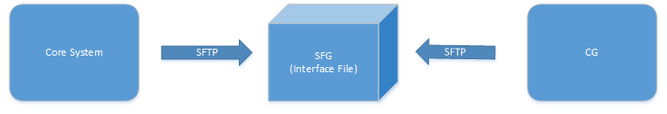

Core System is the application used by AXA to process core business.

The purpose of this interfaces is that CG receives batch notification requests from core system through SFG in a pre-defined time interval.

#### Interface Type

|  |  |  |  |
| --- | --- | --- | --- |
|  | **Inbound** | **Outbound** | **Both** |
| REST |  |  |  |
| Web Service |  |  |  |
| FTP/SFTP | X |  |  |
| Manual |  |  |  |
| Direct File Access |  |  |  |

#### Processing Time:

Pre-defined time

#### Interface Frequency

Pre-defined time interval

#### Expected Volume:

By File size

#### Data Process Flow

Diagram Reference 1.1.1 Overall data flow diagram

Logic Description

1. CG task Scheduler every 5 minutes will obtain with “.nbf” extension file from ftp server.

* Note:.nbf file must is full file. In the process of writing file Please user the other extensions, e.g.. file.tmp ;
* Written after the modification of nbf file.

1. File processing job reads the file first line which is the File header containing information of notification time, message type, request id, Etc.
2. While reading the file content line starting from the second line until the TRL start line.generate notification FK data by business line and message type id.
3. Query file field mapping configuration by business line and message type id.
4. set notification field value by query result .if field is standard field mapping
5. Through field mapping setting generate JSON object (field name :field value )set to notification JSON content field.
6. The notification associated with system Touchpoint
7. One notification resolve end.
8. After the file process completes, move the file to backup folder and generator process log.
9. batch file process end;
10. CG will send notification by Touchpoint

#### Failover or Alternative Flow

Import Notification Source through Notification Management UI.

#### Core System Interface File Definition

File Header

|  |  |  |  |  |  |  |
| --- | --- | --- | --- | --- | --- | --- |
| **#** | **Description** | **Is Required** | **Format** | **Length** | **Sample** |  |
| 1 | File Header | Y | char | 3 | HDR |  |
| 2 | Current Date | Y | YYYYMMDD | 8 | 20160616 |  |
| 3 | Current Time | Y | HHMM | 4 | 1702 |  |
| 4 | Notification Date | Y | YYYYMMDD | 8 |  |  |
| 5 | Business Line Code | Y | Char | 2 | IL |  |
| 6 | Application ID | Y | Char | 5 | G400/EB/RLS/PSEA/FINOS | Reference Only |
| 7 | Touch Point Type | Y | Char | 7 | PNC0001/PNC0002 |  |
| 8 | Content Field Names description | N | Char | 1...line end | PRODUCT_CODE,10 |  |

File Content

|  |  |  |  |  |  |  |  |
| --- | --- | --- | --- | --- | --- | --- | --- |
| **#** | **Field Name** | **Description** | **Is Required** | **Format** | **Length** | **Sample** | **Table Field Mapping** |
| 1 | Field Name | Other field name through file field mapping Configuration | Y | char | Custom |  | Reference explain for  file field mapping configuration Step |

File Header

|  |  |  |  |  |  |
| --- | --- | --- | --- | --- | --- |
| **#** | **Description** | **Is Required** | **Format** | **Length** | **Sample** |
| 1 | File Trailer | Y | char | 3 | HDR |
| 2 | Total Number of Records | Y | Char | 20 | 20160616 |

File Field Mapping Configuration Step

1. Business Line & Touchpoint Type is must exist through CG system menu step -> business line maintenance;

Screenshot:

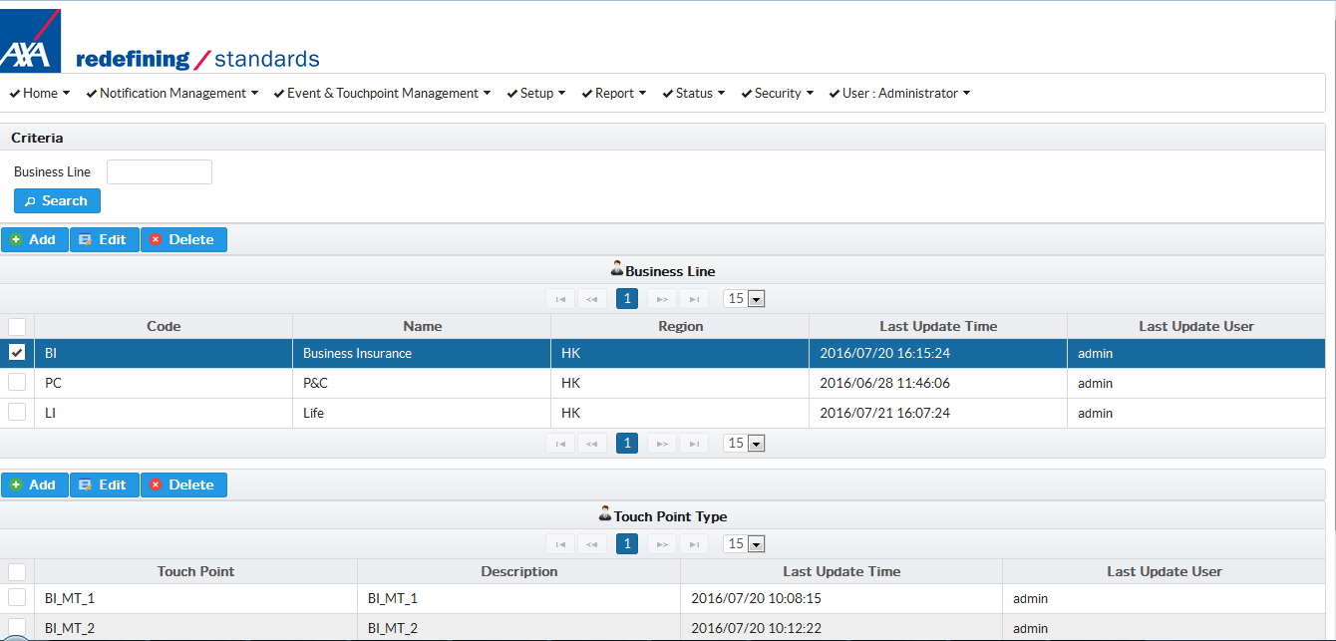

1. Add business line ：code value equal business line field value in file content；
2. After Business line added, select business line in Business line table;
3. Create Touch Point Type, input Touchpoint type id equals message type id in file header.
4. add all Touchpoint types for business line
5. Add File field Mapping through menu Step->File field mapping

Screenshot:

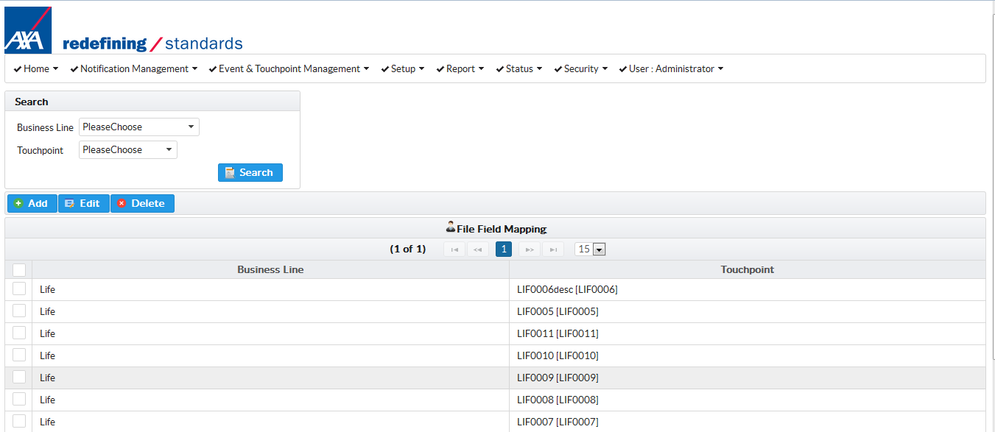

1. click add button add File field mapping
2. select business line and Touchpoint
3. 3）input field information in add Field Screen.

Screenshot

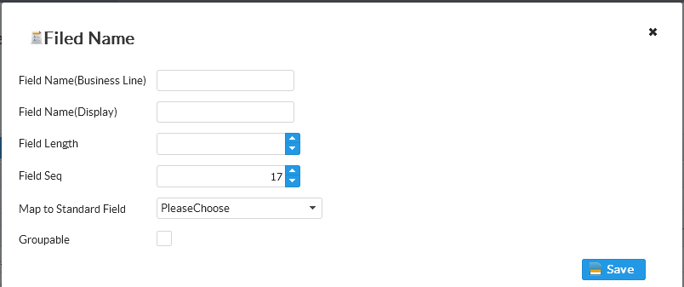

Explain for screenshot;

Field Name (System): input system field name not constraint

Field Name (Display): input field description not constraint.

Field Length: field have length in file content line .the length must accuracy, otherwise file resolve result uncertainty.

Field Seq: field index in file content line. Field value resolve by Seq and length automatic calculate start and end position in content line;

Map to Standard Field: indicates the field is system Standard Field. If the indicator is enabled, relevant field value will automatic mapped into notification standard field.

Groupable: if this indicator is enabled, the field will appear in Touchpoint template placeholder options, allowing user to flexibly format it in the template content.

*Note: Field mapping configuration is important and cautious. Field length and seq cannot be wrong and need to be exact match with the interface file content line.*

File Trailer

|  |  |  |  |  |  |  |  |
| --- | --- | --- | --- | --- | --- | --- | --- |
| **#** | **Field Name** | **Description** | **Is Required** | **Format** | **Length** | **Sample** | **Table Field Mapping** |
| 1 | File Trailer | File Trailer | Y | char | 3 | TRL |  |
| 2 | Number of Records | Total no. Of records in the file | Y | char | 20 |  |  |

#### Interface Data Direction Relative to CG System

[ X ] Inbound

[ ] Outbound

[ ] Both (bi-directional)

#### Interface Log

Generate log file in complete folder

#### Return Code Values

Not Return

#### Overall format and sample layout

HDR201607071620RLS BUSINESS_LINE,2;

LIAAA0 REB0PNO0 2016/07/07

TRL1